Chapter 16, Problem 42.

Given the circuit in Fig. 16.65, find i(t) and v(t) for t > 0.

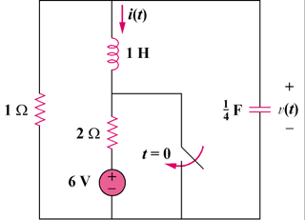
12 V

Figure 16.65
For Prob. 16.42.

